**PBJ Documentation**

This documentation contains a detailed procedure on how to make an American delicacy, a peanut butter and jelly(PBJ) sandwich. A PBJ sandwich contains a layer of peanut butter and jelly between two slices of bread. The final product, the PBJ sandwich, should look a lot like the picture shown below:

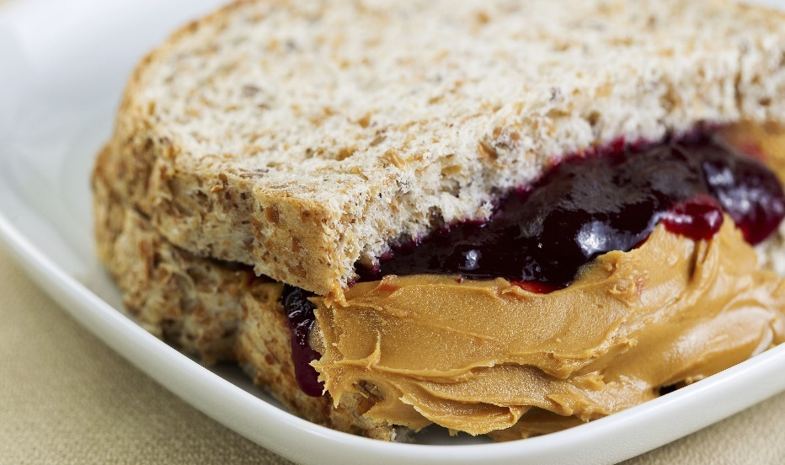

Figure 11

Before getting to the steps, there are a few kitchenware and ingredients that are required. For the kitchenware, a chopping board (or even a plate would work fine), a butter knife, a knife and a spoon is required. The ingredients require a jar of peanut butter, a jar of jelly (or jam) and a sliced loaf of bread.

Steps for making a PBJ sandwich:

1. Take 2 slices from the sliced loaf of bread and place them on the plate as shown below. The bread can be toasted first or grilled depending on the person who is going to eat the sandwich.

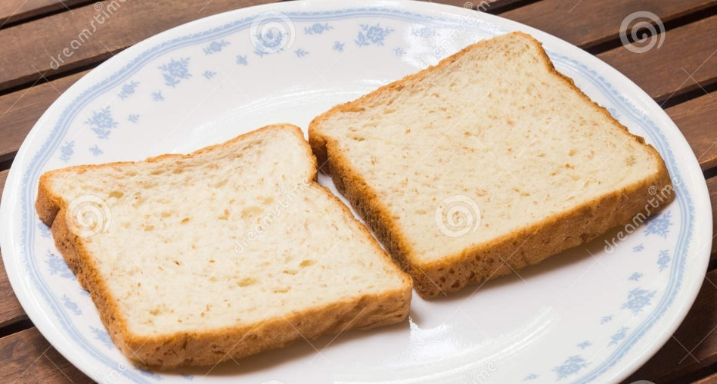

Figure 2 2

1. Open the jar of jelly or jam, take a scoop of jelly (the scoop can be large or small depending on the eater) with the spoon and put it on the side of the bread facing upwards. Take the butter knife to spread the jelly all over the bread as shown below.

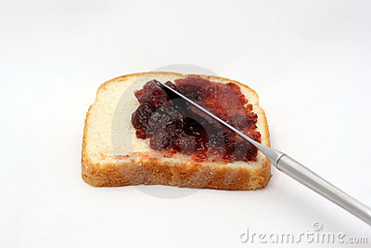

Figure33

1. Clean the spoon to avoid mixing the jelly with peanut butter in the jar. Don’t need to apply this for the butter knife.
2. Open the jar of peanut butter, take a scoop of peanut butter (the scoop can be large or small depending on the eater) with the spoon and place it on the side of the second bread facing upwards. If the peanut butter is hard, wait for it to soften a bit. Take the butter knife to spread the peanut butter all over the bread. After this step, you would have this image shown below:

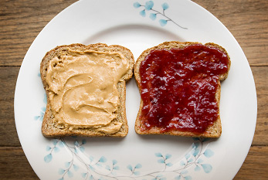

Figure 44

1. Now press the two slices of bread with the sides containing peanut butter and jelly facing each other. Now you have a PBJ sandwich that looks something like the image below:

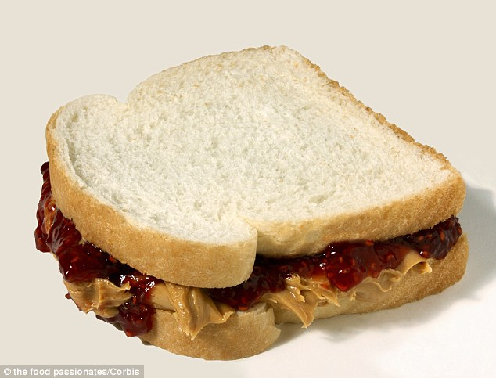

Figure 55

1. Use a knife to cut the bread into equal halves or to remove the crust if the eater isn’t a huge fan of the crusts. Now you have a ready to eat PBJ sandwich.

Word Count: 373

References:

1. Network, L. D. (2014). National PB&J Day: Dance, sing with banana meme. Retrieved October 26, 2016, from <http://www.usatoday.com/story/news/nation-now/2014/04/02/peanut-butter-jelly-time/7194151/>
2. Retrieved October 26, 2016, from <http://2.https://www.dreamstime.com/stock-photo-two-slices-plain-wholemeal-bread-plate-image54203880>
3. Retrieved October 26, 2016, from <http://3.https://www.dreamstime.com/stock-photo-two-slices-plain-wholemeal-bread-plate-image54203880>
4. Retrieved October 26, 2016, from <http://4.https://www.dreamstime.com/stock-photo-strawberry-jelly-bread-spread-image16687660>
5. Retrieved October 26, 2016, from <http://5.http://www.cute-calendar.com/event/national-peanut-butter-and-jelly-day/20529.html>